1) Classification Algorithm
a) Age <30 and Govt satisfaction less ,urban
b) Age >50 and Govt statisfaction less ,non urban
validate the percentage
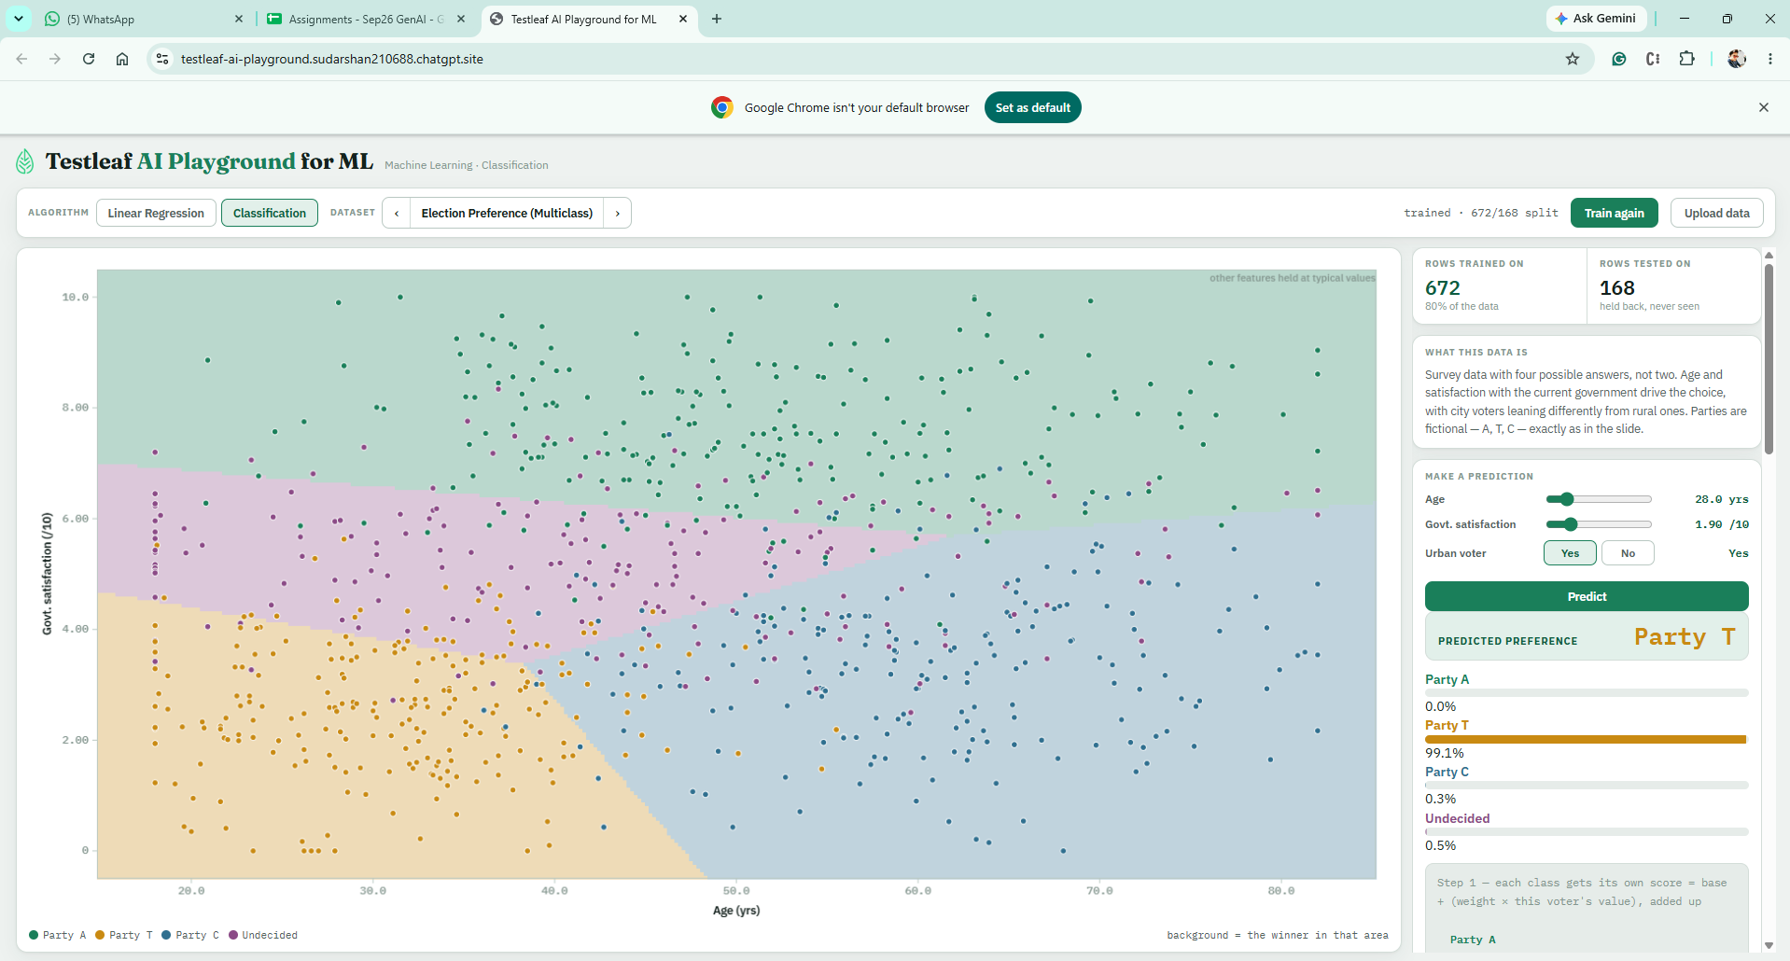
b) Age >50 and Govt statisfaction less ,non urban

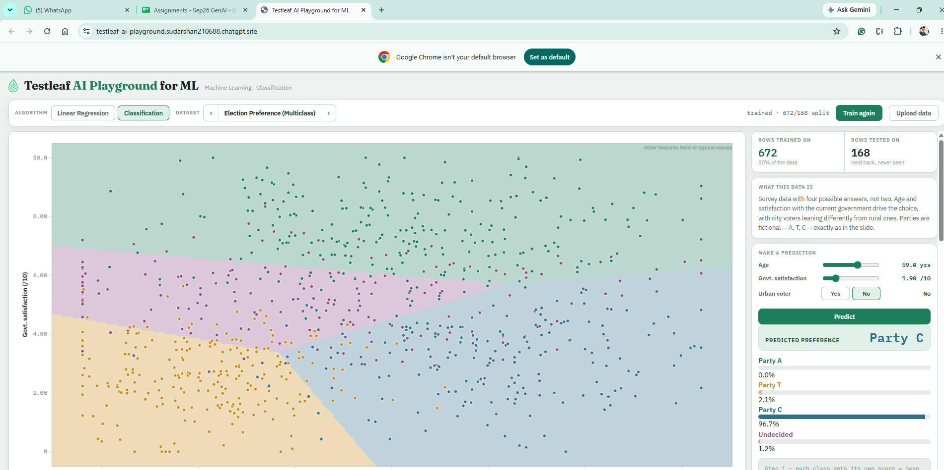

2)Linear regerssion
a) QA Salary
b) Food Delivery time
Check the Calculation for price and time

